--------------------------------------------------------------------------------------------------------------------------------------------------------

Editing Notes from the Poo Bah (who happens to be nuts).: Editing is in progress. Document will be resequenced at some point. IS AIN’T DONE YET!

--------------------------------------------------------------------------------------------------------------------------------------------------------

***(Thanks Poo Bah… I will be back to add some order and more info…***

***This project is still in progress… I am also working in another “floating ball” project (also to be documented) Vicente /07 APR 2017)***

Some work in progress....

First, we need a lamp to produce a easy to detect shadow in the wall :

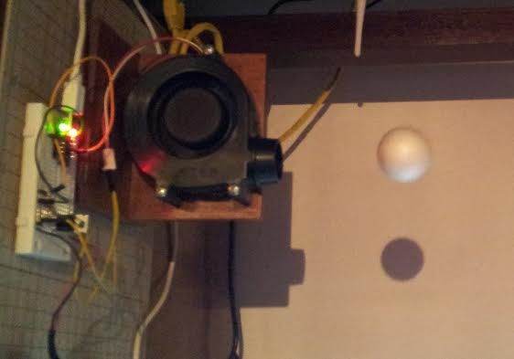

Next, design a shadow edge detector:

Two 100 ohm resistor are used to limit the current in case of a very high intensity light ...

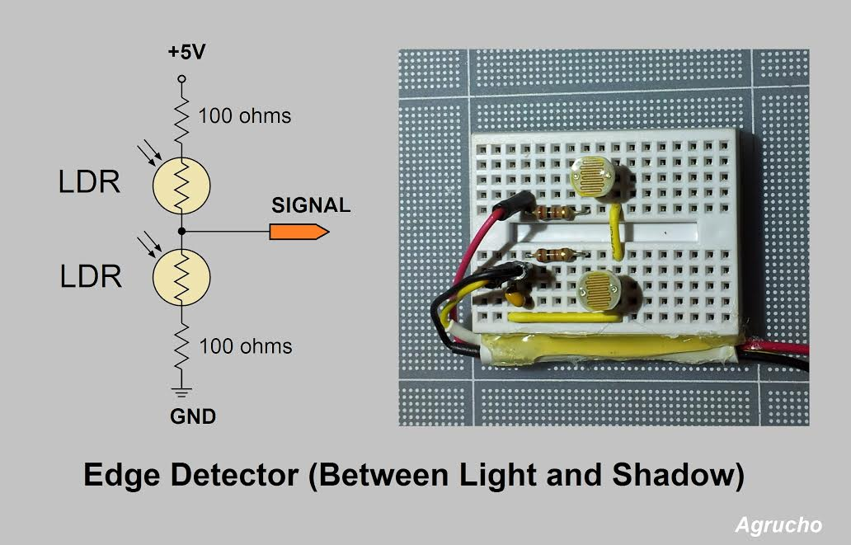

​

Making some tests using an oscilloscope :

When both LDSs have the same amount of light the voltage is near the middle (2.5 Volts).

If the photocells are in the transition from light to shadow the voltage increase or decrease

depending on the direction of the transition.

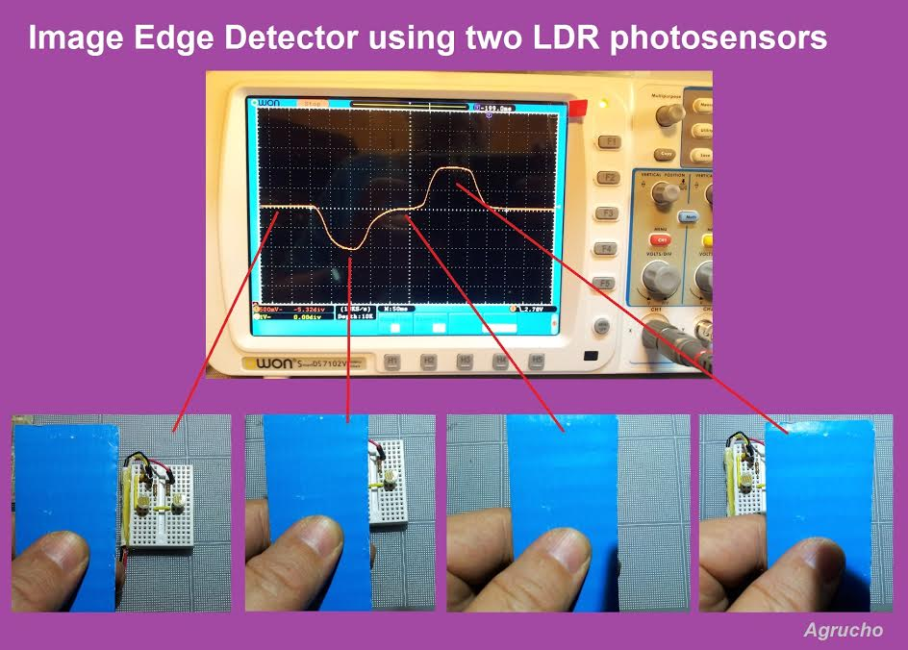

​

Well , everything is going smoothly (until now).

Need to write some code to see how this thing behaves...

But first need to run (or walk) some kilometers...

May be later...

On Mon, Feb 27, 2017 at 2:57 PM, Vicente González <agrucho@gmail.com> wrote:

Thanks Jim.,

Will try to use LDR photocells to sense the projected shadow in the wall behind...

On Feb 27, 2017 1:52 PM, "James McCrary" <jim.mccrary@gmail.com> wrote:

Measurement of position could be interesting.

photosensors hi/low middle?

photo diode array?

ultrasonic (at bottom or top)

On Sun, Feb 26, 2017 at 7:36 PM, Vicente González <agrucho@gmail.com> wrote:

Just playing with "floating" ideas...

Using the Adafruit's TRINKET (ATTINY85) to control a polystyrene ball position in the air.

Turbofan PWM controlled.

A feedback position must be added to the experiment.

Initially try to use a plastic tube but I need to find a heavier or smaller ball to continue the experiment.

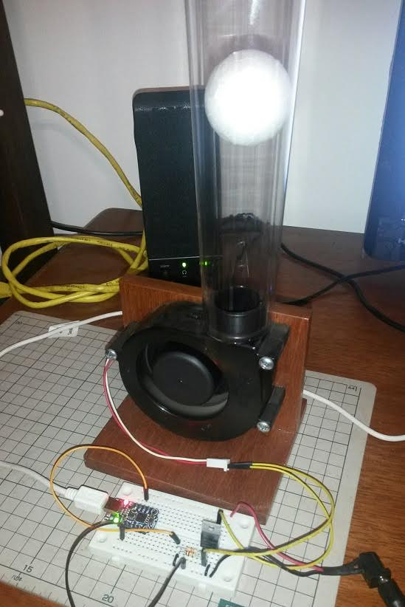

Without the tube there are also many possibilities...

May be interesting to implement a PID example or use several turbofans controlling balls in a musical ball dancing exhibition...

... just exercising **out-of-the-box** thinking ....

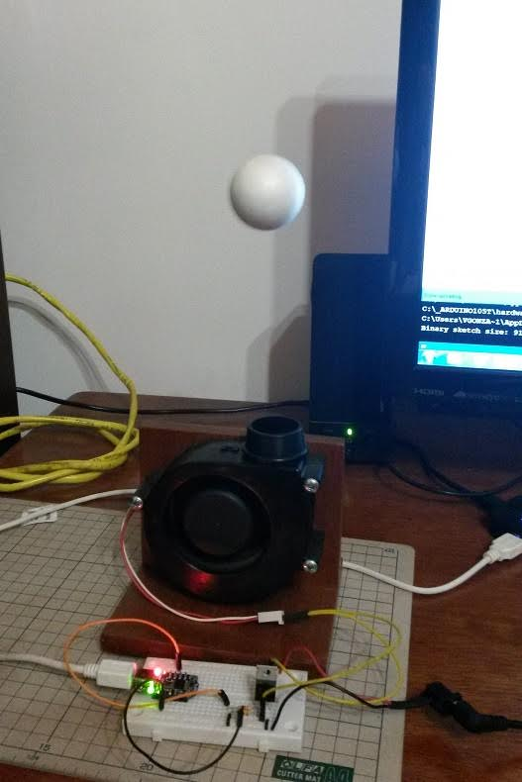

The fan is controlled using PWM with a MOSFET driver.

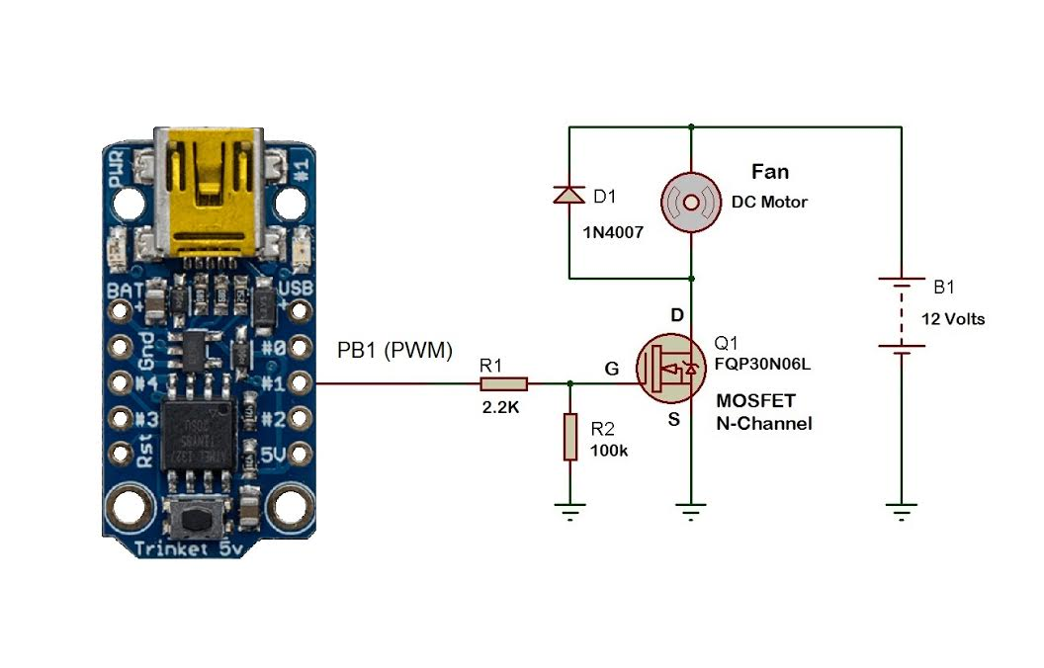

Diagram of the MOSFET driver controlled by the Arduino TRINKET (Adafruit).

*Figure 2 - Edge Detector (Sensor Assembly) installed on the wall:*

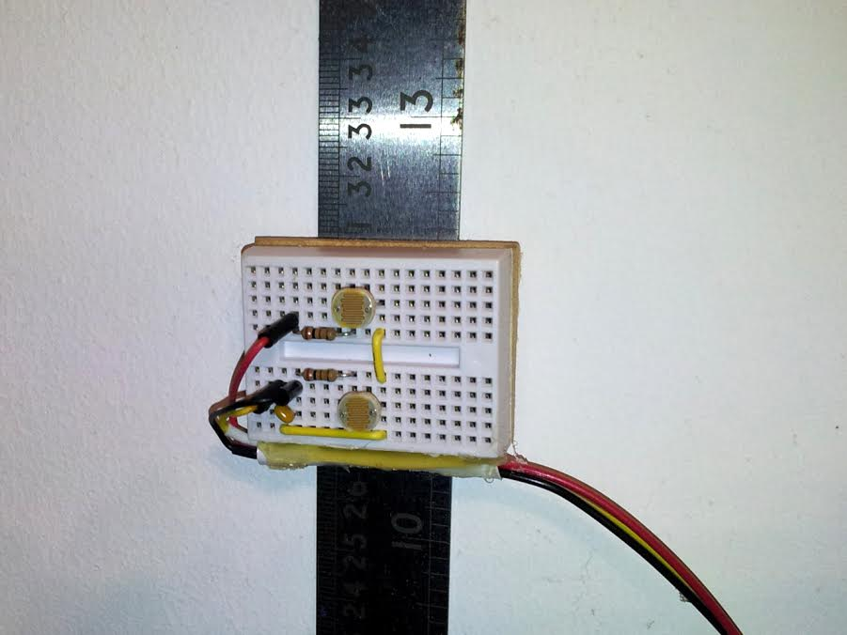

A Stainless Steel Ruler was glued in the wall using double face tape.

**Attaching the Sensor Assembley to the ruler.**

We installed two magnets on the back of a piece of wood.

The wood is then attached to the mini breadboard (sensor assembly).

The resulting assembly can then be attached to the ruler at any height.

*Figure 1 Putting Magnets on the piece of wood.*

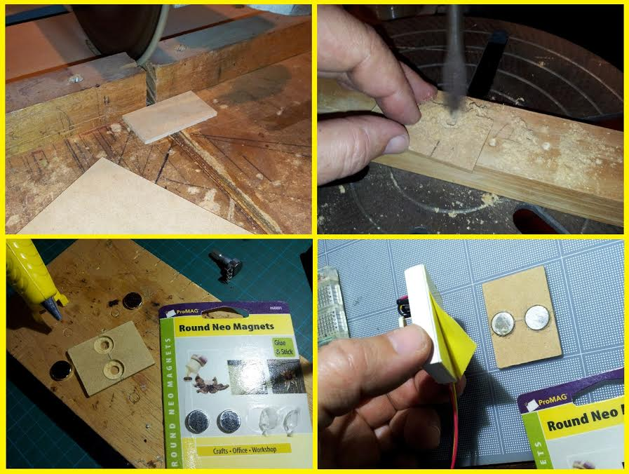

Two neodymium magnets were attached to the breadboard using a piece of wood (MDF).

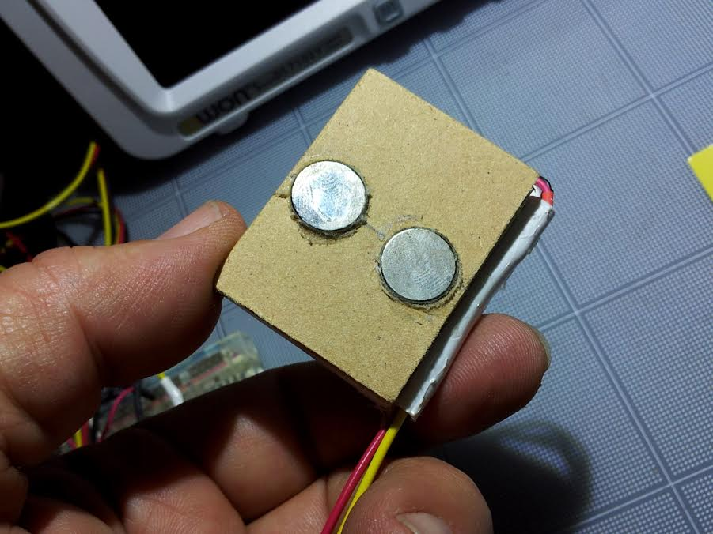

​Now all the hardware is ready:

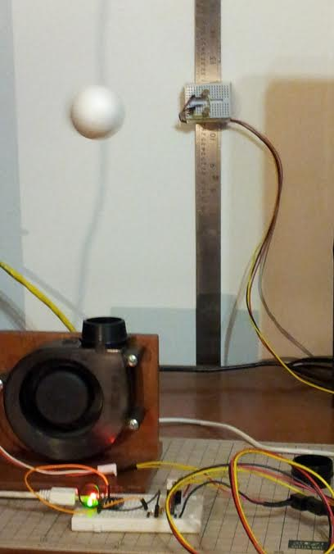

Thinking in to change the TRINKET for an Arduino NANO, the TRINKET does not use the Serial Terminal (no serial communications).

I need to see some data in the Serial Terminal to adjust the control parameters.

Everything looks OK, Hope it will work...



On Mon, Feb 27, 2017 at 5:18 PM, Vicente González <agrucho@gmail.com> wrote:

Some work in progress....

First, we need a lamp to produce a easy to detect shadow in the wall :

